  - ENEMLOS NEWSLETTER Issue 1/2022
January/February/March 2022
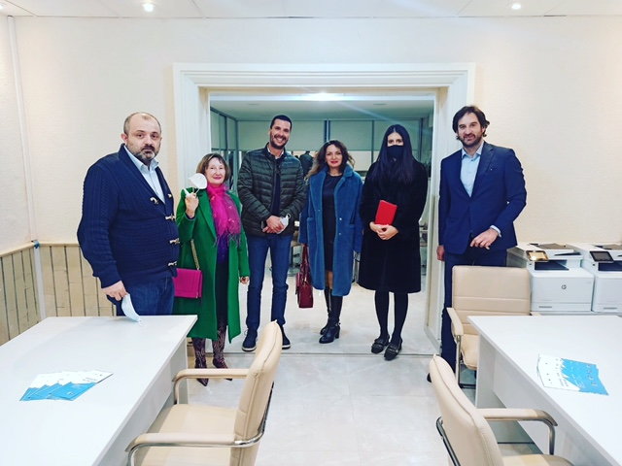 |  |  | 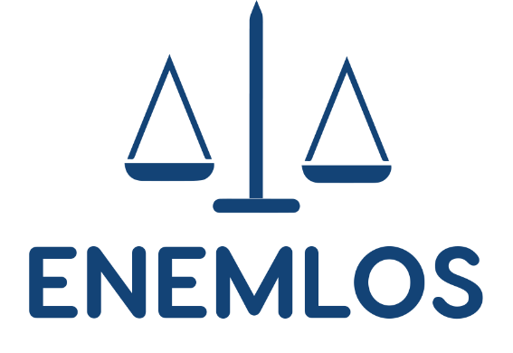  LEGAL CLINICS IN SERVICE OF VULNERABLE GROUPS: ENHANCING THE EMPLOYABILITY OF LAW STUDENTS THROUGH PRACTICAL EDUCATION
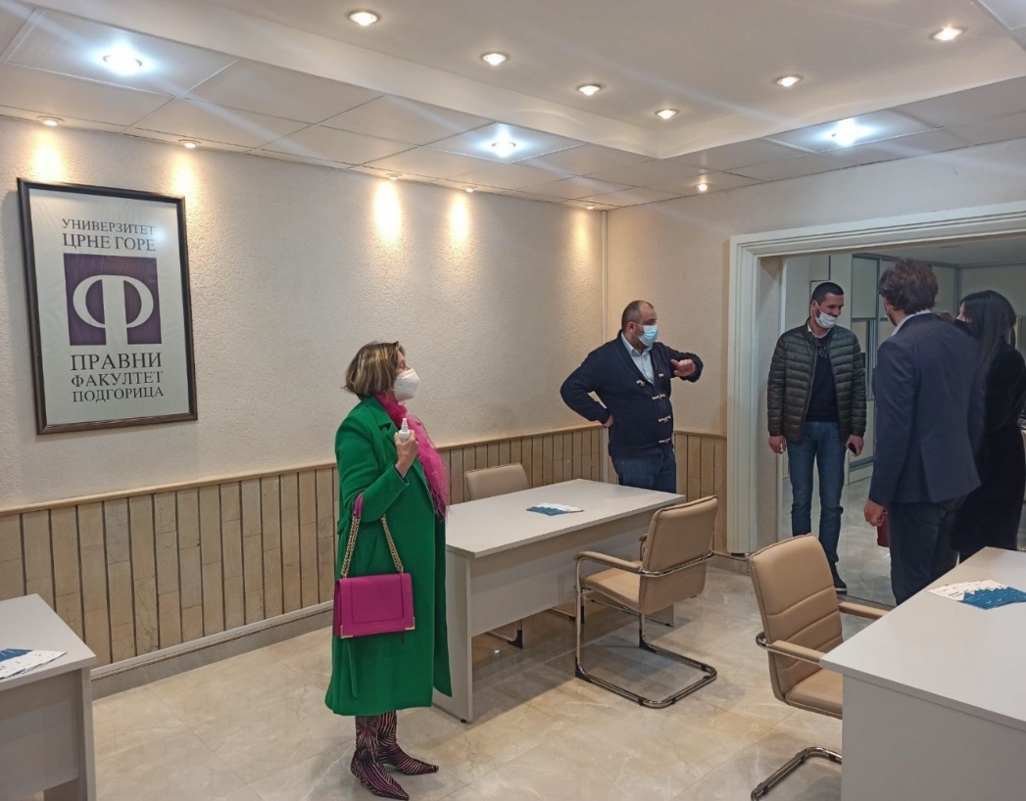 |  |  | IN THIS ISSUE:  THE PROJECT MANAGEMENT TEAM ACTIVITIES  Members of the ENEMLOS project team and representatives of non-academic partners in the project held a meeting at the Faculty of Law on 17th February 2022
–––––––

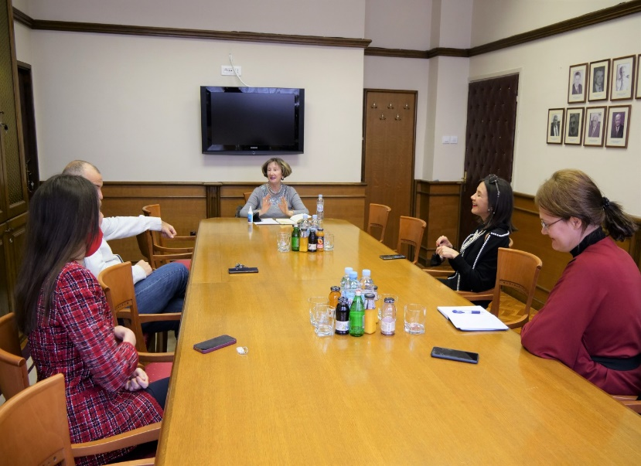
THE PROJECT MANAGEMENT TEAM MEETING
1ST FEBRUARY 2022

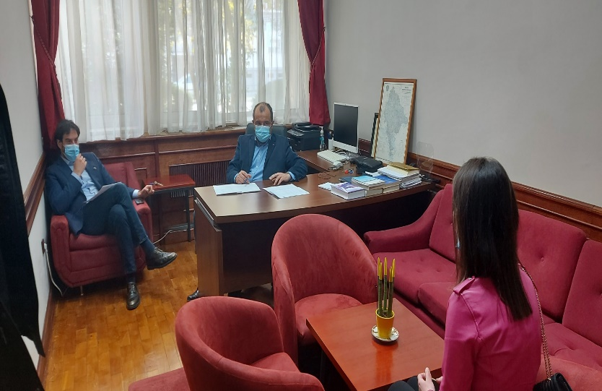
Podgorica, the Faculty of Law, 21st March 2022:
Members of the project management team organized interviews in order to make an election of students who applied for work at the legal clinics
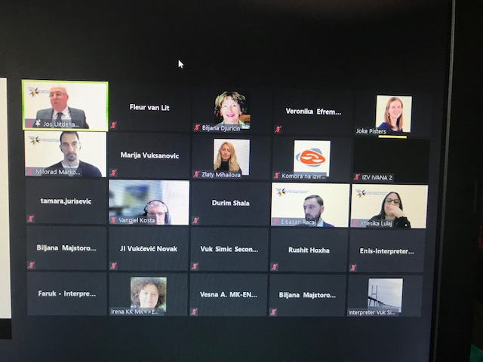

The Center for International Legal Cooperation from Hague organized a regional workshop on guidelines for the development of a normative framework for professional behavior and responsibilities of enforcement agents on February 28, 2022
This was one of the first workshops in cooperation between the CILC and the project ENEMLOS
Members of the Chamber of Judicial Officers from Montenegro, partner institutions representatives, as well as representatives from the Faculty of Law participated in the workshop

